**House Keeper Scheduling System:**

**Services:**

|  |
| --- |
| Services Name |
| Admin |
| User |
| Worker |
| CleanRequest |
| Feedback |

**MySql:**

|  |  |  |  |
| --- | --- | --- | --- |
| Table Name | Columns | Primary Key | Foreign keys |
| admin | admin_id, hostel, password, username | admin_id | - |
| user | rollnumber, hostel, password, room | rollnumber | - |
| worker | worker_id, floor, hostel, name | worker_id | - |
| feedback | feedback_id, feedback, request_id, rollnumber | feedback_id | cleanrequest(request_id), student(rollnumber) |
| Cleanrequest | request_id,clean_time,date,feedback_status,req_status,rollnumber,worker_id | request_id | student(rollnumber), worker(worker_id) |

**Admin:**

CREATE TABLE `admin` (

`admin_id` int NOT NULL AUTO_INCREMENT,

`hostel` varchar(255) DEFAULT NULL,

`password` varchar(255) DEFAULT NULL,

`username` varchar(255) DEFAULT NULL,

PRIMARY KEY (`admin_id`)

)

**User:**

CREATE TABLE `student` (

`rollnumber` bigint NOT NULL,

`floor` int NOT NULL,

`hostel` varchar(255) DEFAULT NULL,

`password` varchar(255) DEFAULT NULL,

`room` varchar(255) DEFAULT NULL,

PRIMARY KEY (`rollnumber`)

)

**Worker:**

CREATE TABLE `worker` (

`worker_id` bigint NOT NULL AUTO_INCREMENT,

`floor` int NOT NULL,

`hostel` varchar(255) DEFAULT NULL,

`name` varchar(255) DEFAULT NULL,

PRIMARY KEY (`worker_id`)

)

**Clean request:**

CREATE TABLE `clean_request` (

`request_id` bigint NOT NULL AUTO_INCREMENT,

`clean_time` time DEFAULT NULL,

`date` date DEFAULT NULL,

`feedback_status` bit(1) NOT NULL,

`req_status` bit(1) NOT NULL,

`rollnumber` bigint DEFAULT NULL,

`worker_id` bigint DEFAULT NULL,

PRIMARY KEY (`request_id`),

KEY `FK47xo5vv6uu6wh6cauwq03f51k` (`rollnumber`),

KEY `FKf0q0yidj1oes6yg82se2qbdf3` (`worker_id`),

CONSTRAINT `FK47xo5vv6uu6wh6cauwq03f51k` FOREIGN KEY (`rollnumber`) REFERENCES `student` (`rollnumber`),

CONSTRAINT `FKf0q0yidj1oes6yg82se2qbdf3` FOREIGN KEY (`worker_id`) REFERENCES `worker` (`worker_id`)

) ENGINE=InnoDB DEFAULT CHARSET=utf8mb4 COLLATE=utf8mb4_0900_ai_ci;

**Feedback:**

CREATE TABLE `feedback` (

`feedback_id` bigint NOT NULL AUTO_INCREMENT,

`feedback` varchar(3000) DEFAULT NULL,

`request_id` bigint DEFAULT NULL,

`rollnumber` bigint DEFAULT NULL,

PRIMARY KEY (`feedback_id`),

KEY `FK96upbmjce91hbagr6030dy3ny` (`request_id`),

KEY `FK2257spm361ysobt3ecj8d5vry` (`rollnumber`),

CONSTRAINT `FK2257spm361ysobt3ecj8d5vry` FOREIGN KEY (`rollnumber`) REFERENCES `student` (`rollnumber`),

CONSTRAINT `FK96upbmjce91hbagr6030dy3ny` FOREIGN KEY (`request_id`) REFERENCES `clean_request` (`request_id`)

) ENGINE=InnoDB DEFAULT CHARSET=utf8mb4 COLLATE=utf8mb4_0900_ai_ci;

**Postman Screenshots:**

**Admin:**

**getAdmin:**

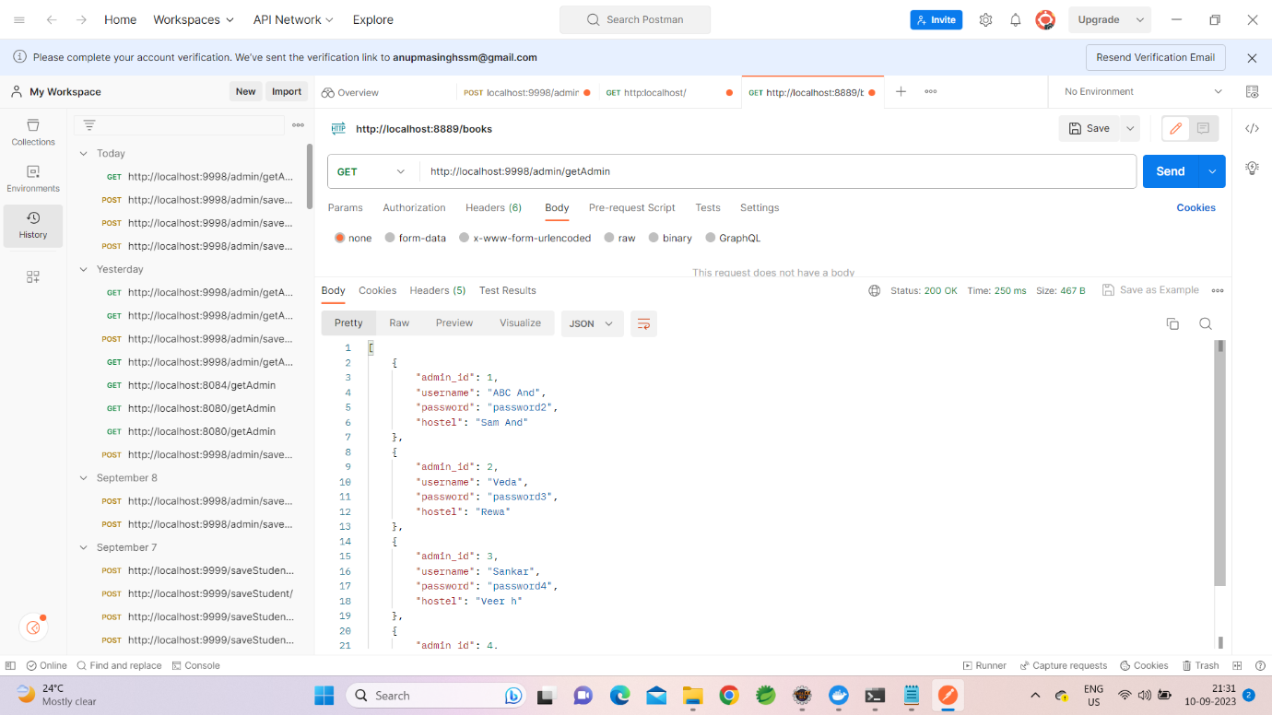

**getAdminById:**

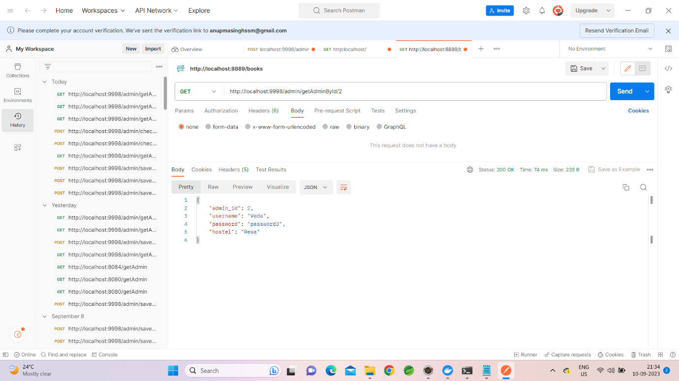

**saveAdmin:**

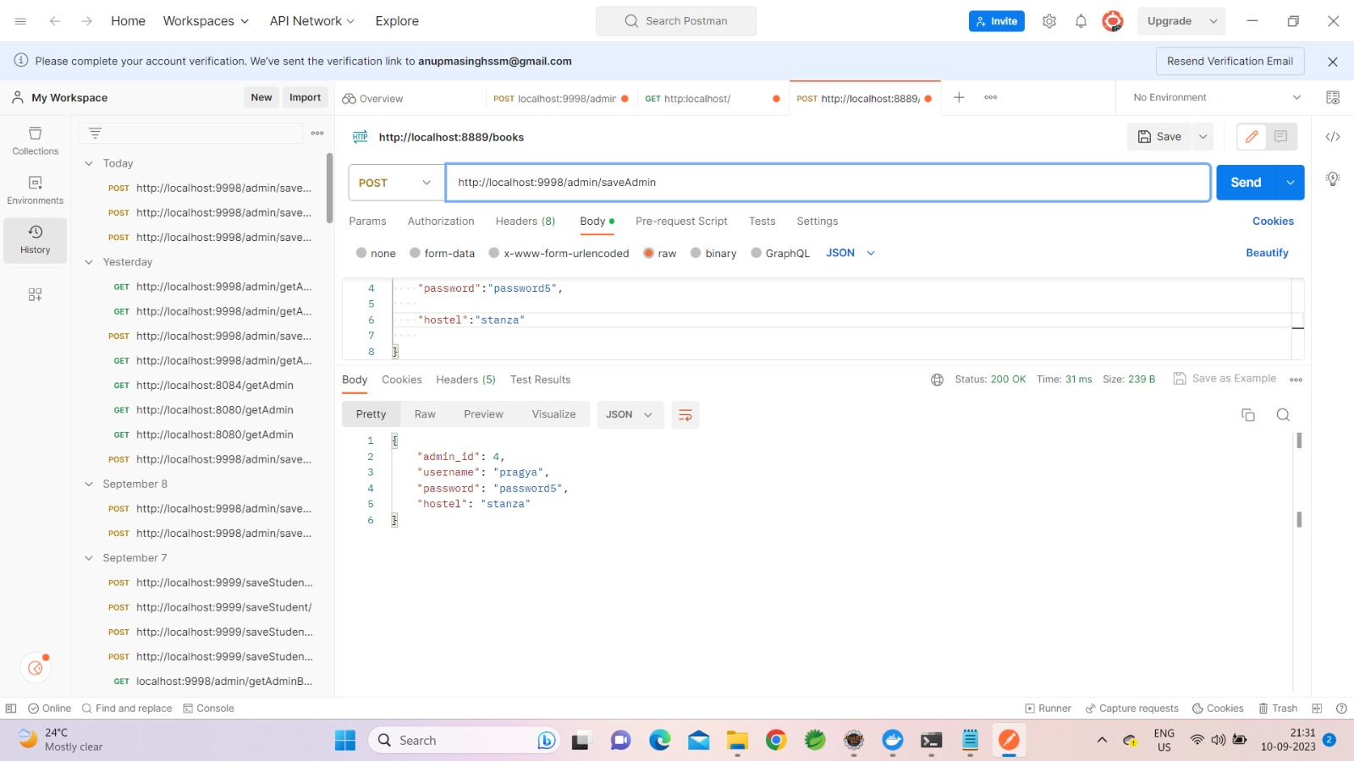

**Student:**

**getAllStudent:**

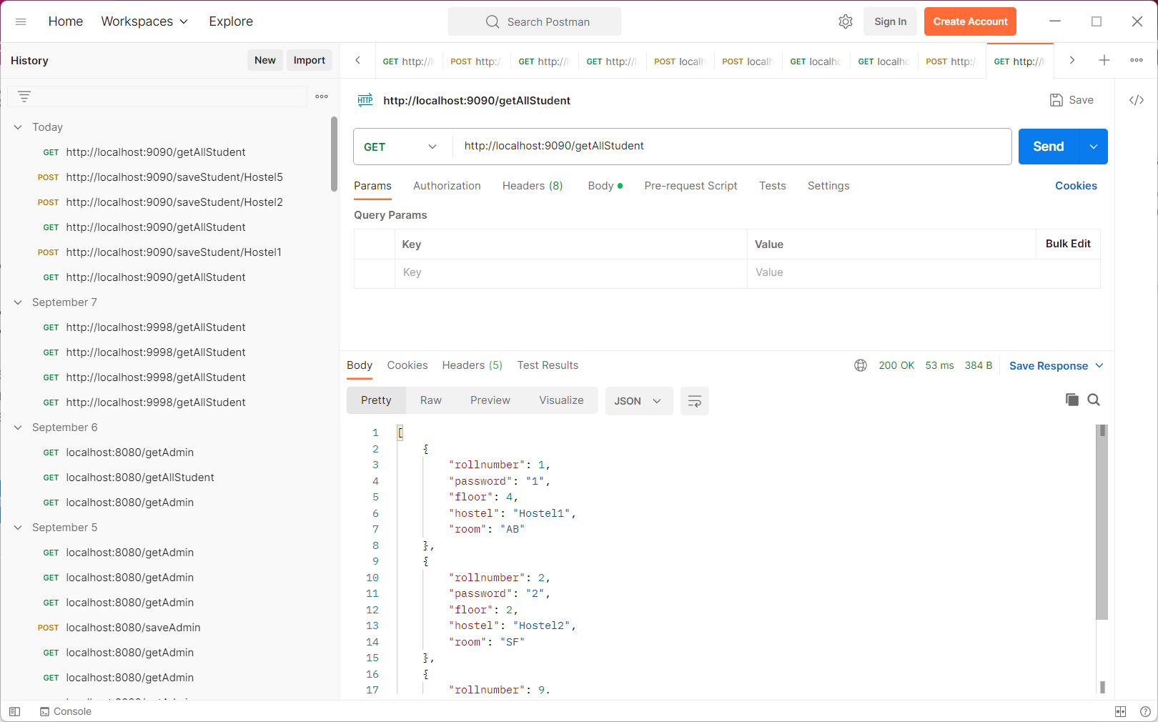

**changePasswordOfStudent:**

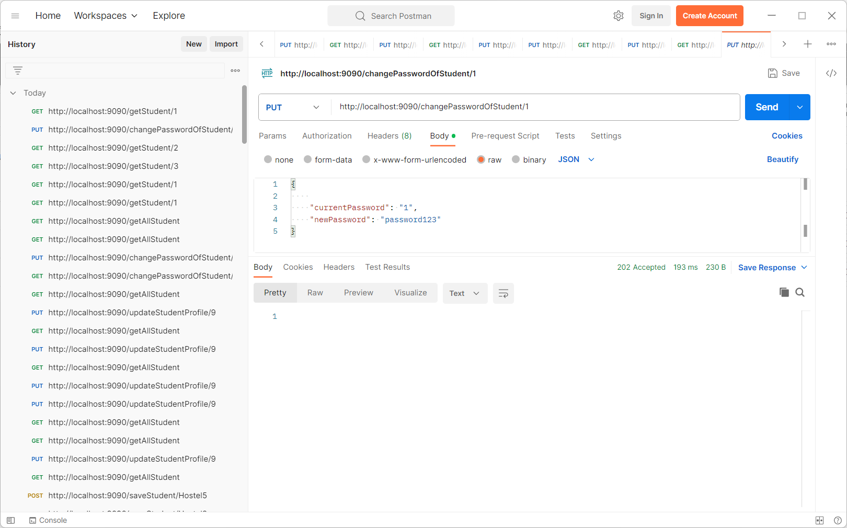

**getStudent:**

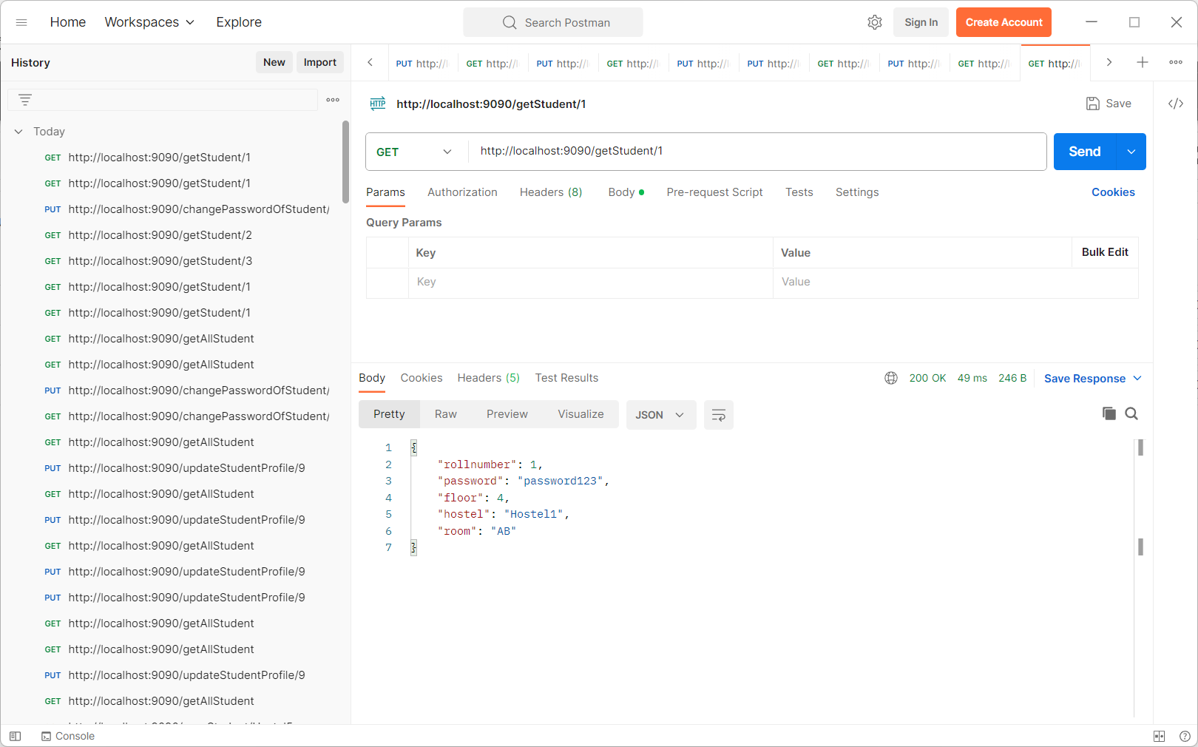

**updateStudent:**

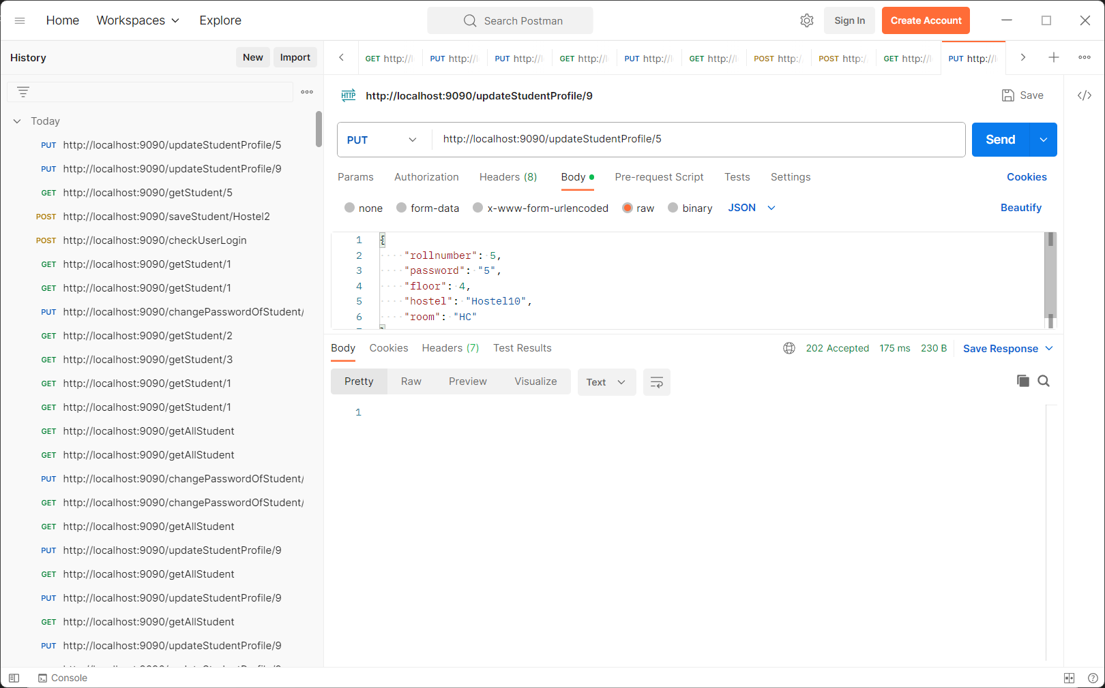

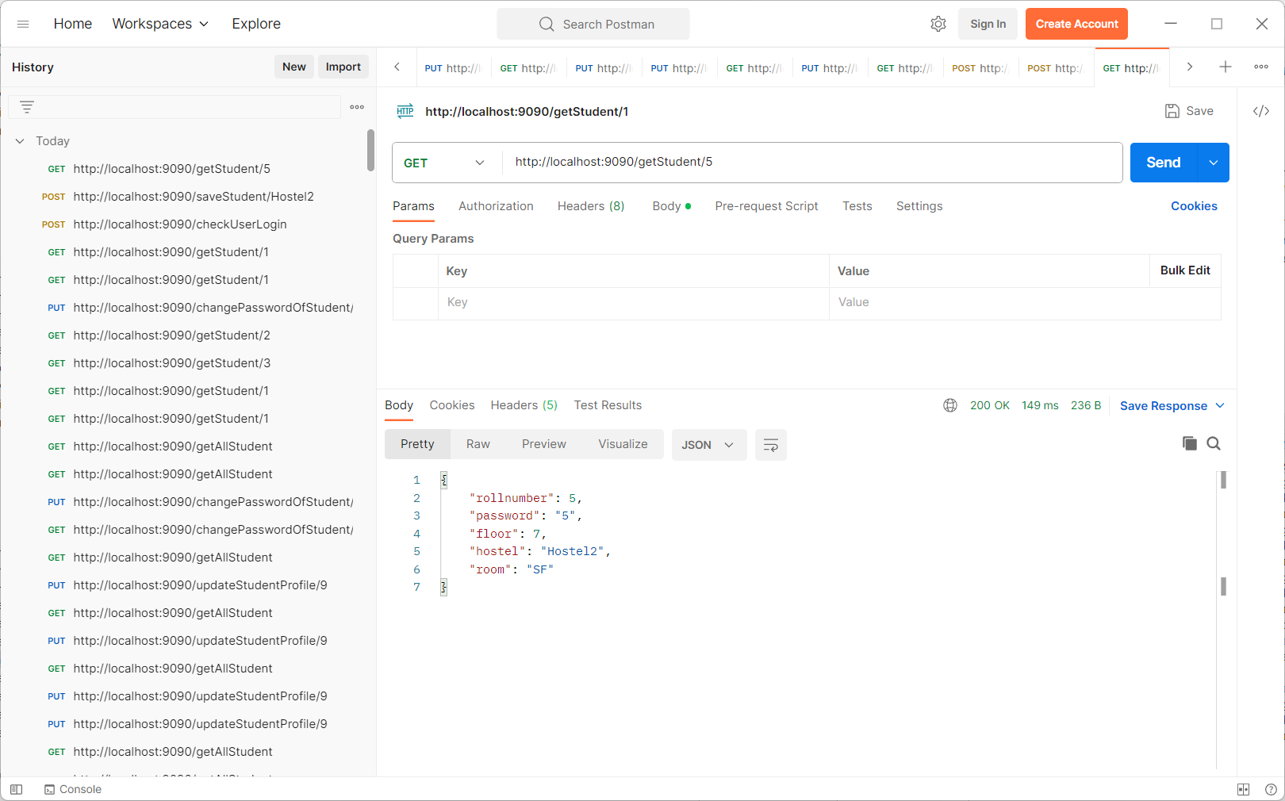

**saveStudent:**

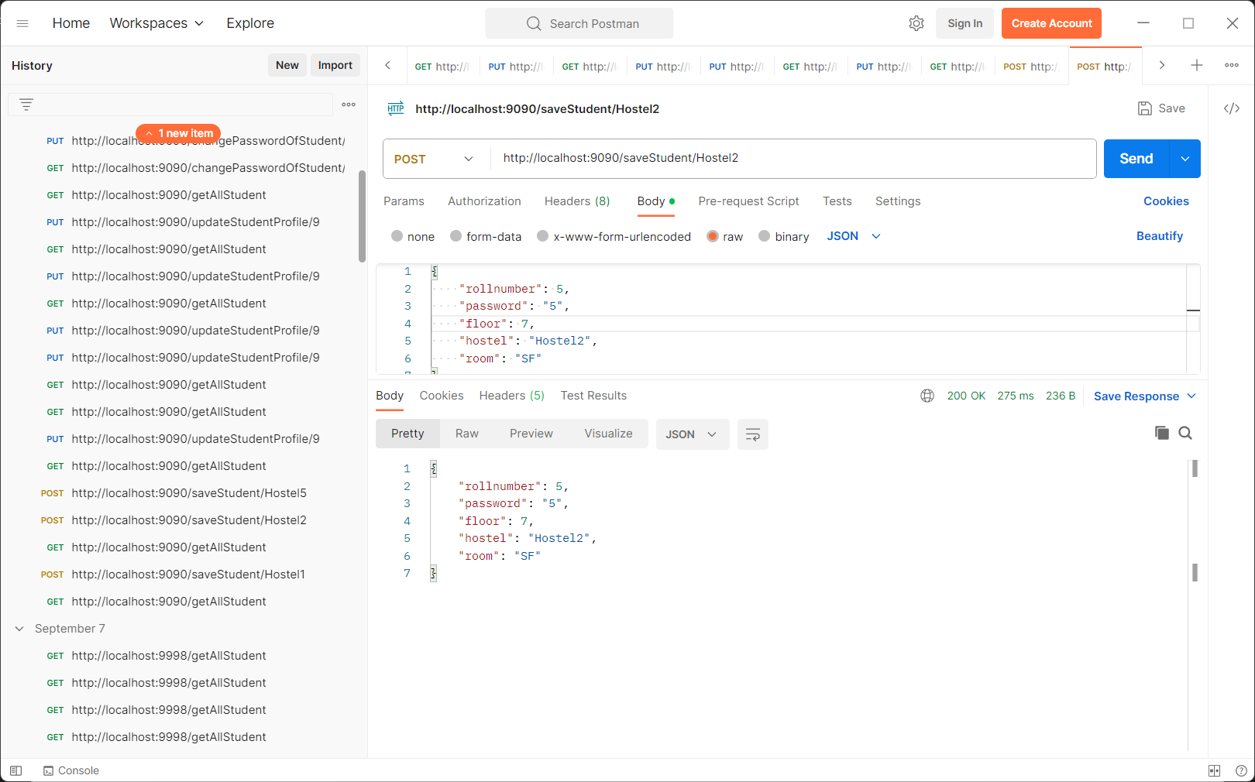

**checkUserLogin:**

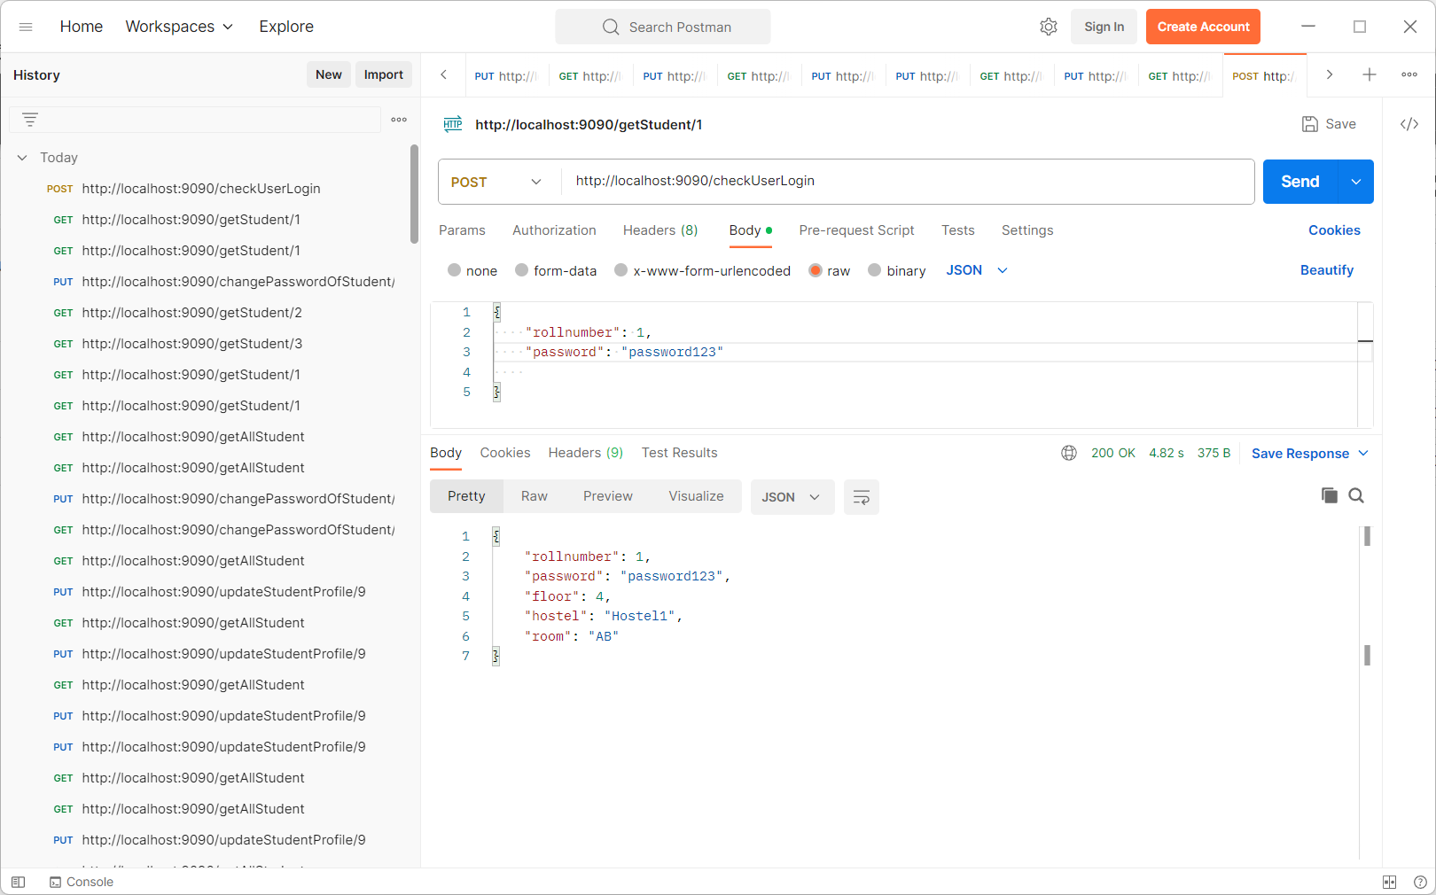

**Worker:**

**registerWorker:**

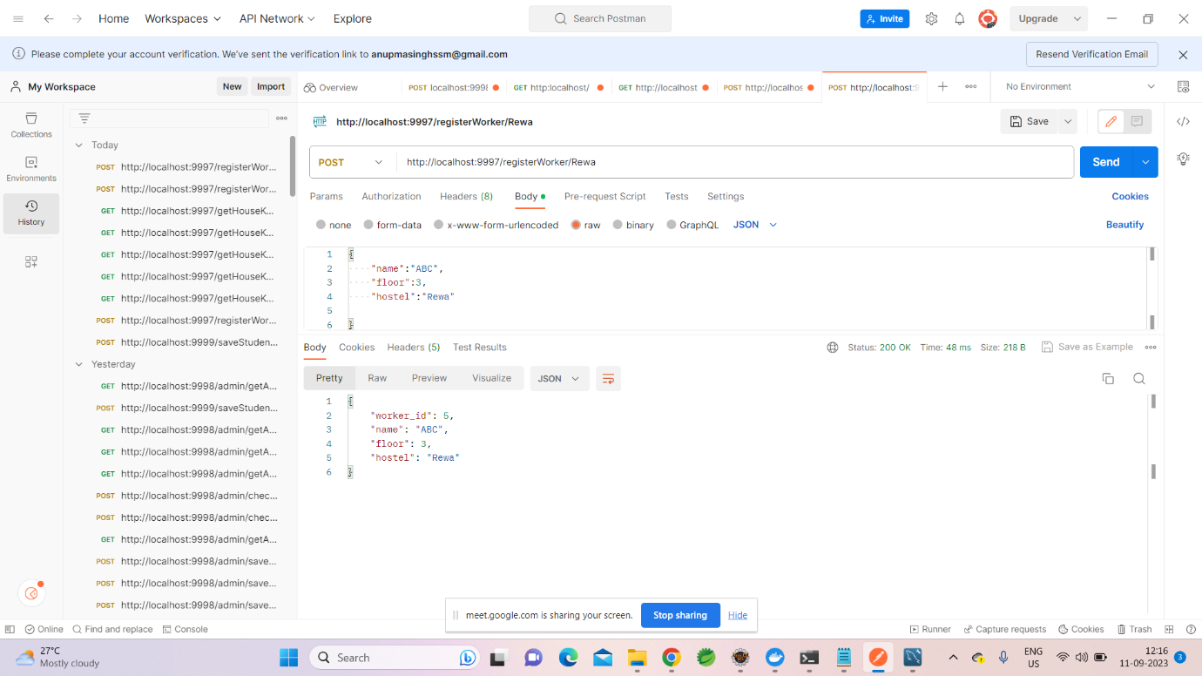

**getHouseWorkerByFloor:**

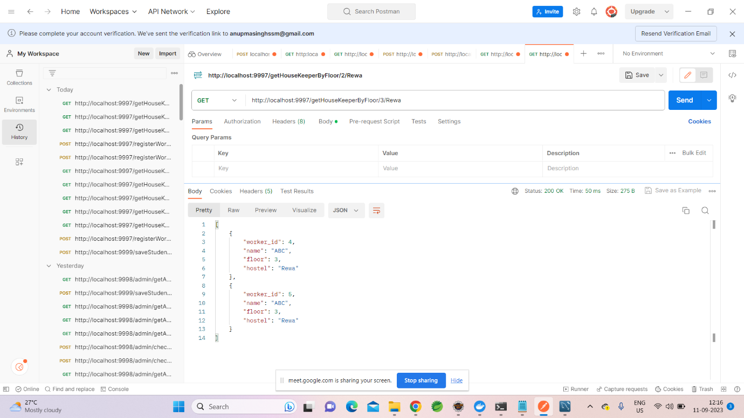

**Cleanrequest:**

**allotHouseKeeper:**

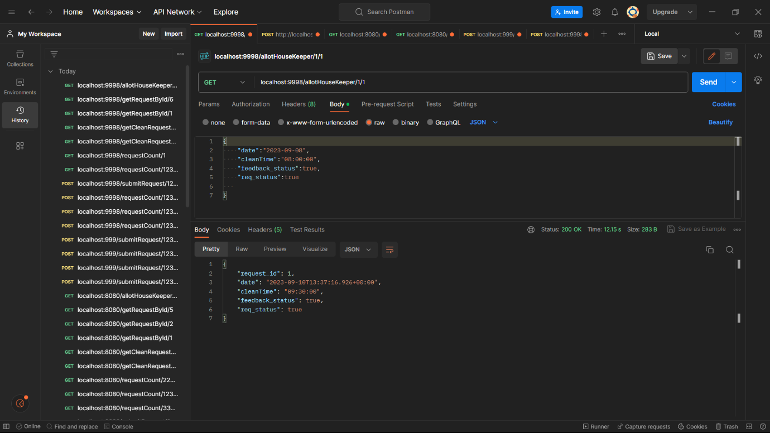

**getRequestById:**

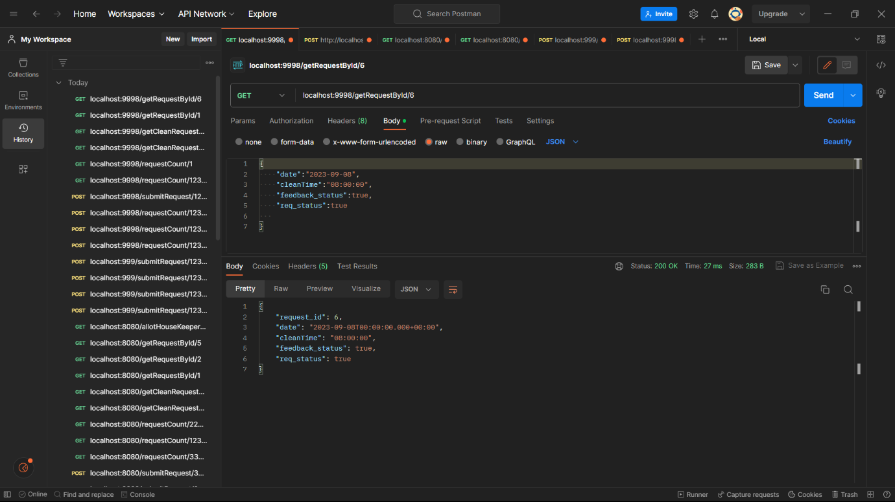

**getRequestByRollnumber:**

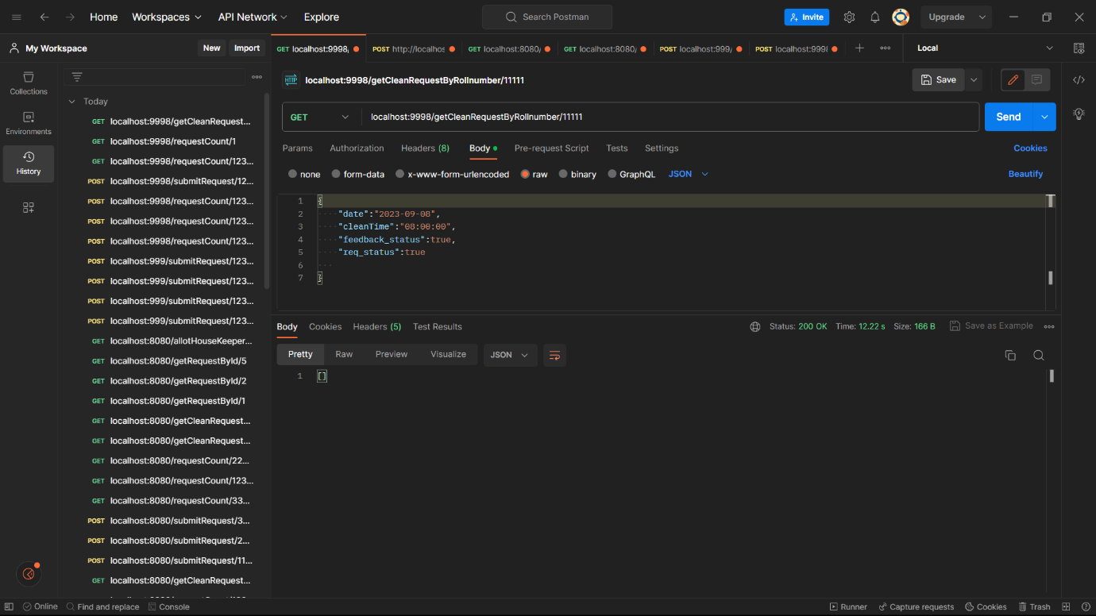

**submitRequest:**

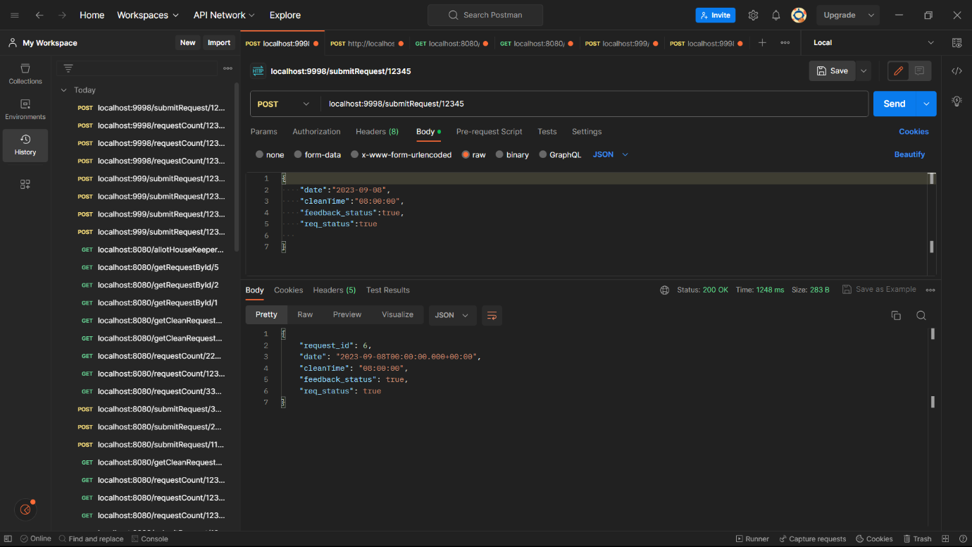

**getCleanRequestByHostel:**

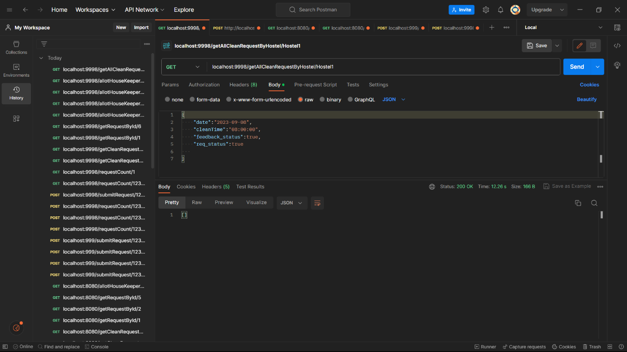

**Feedback:**

**getfeedbackCountByHostel:**

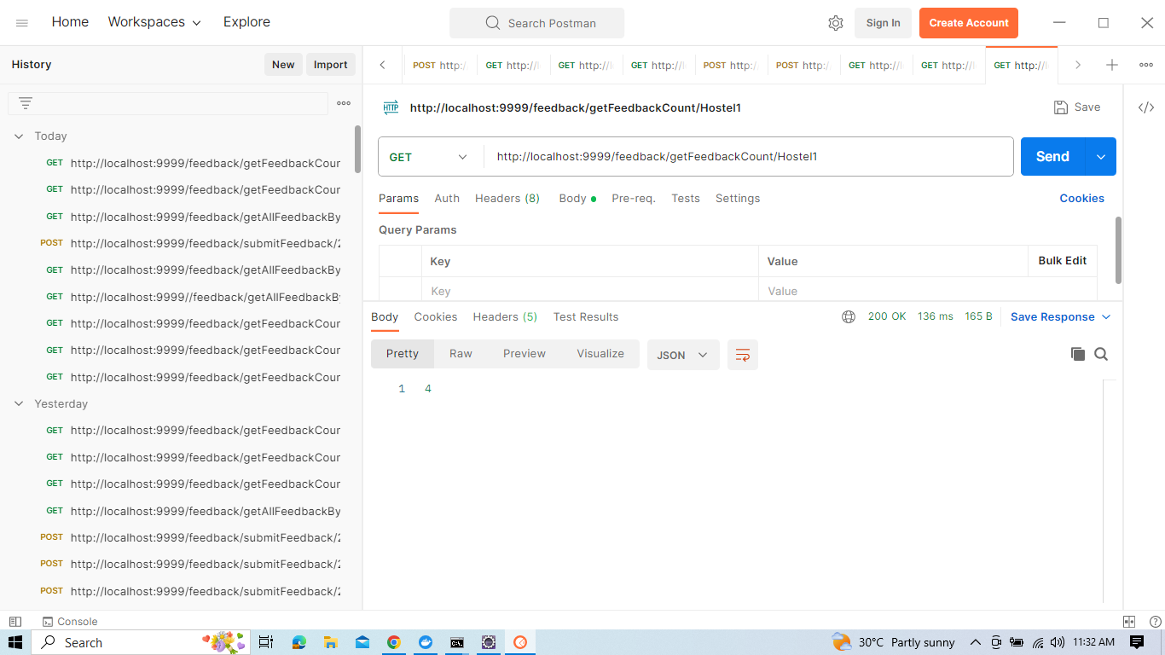

**getFeedbackCountByrollnumber:**

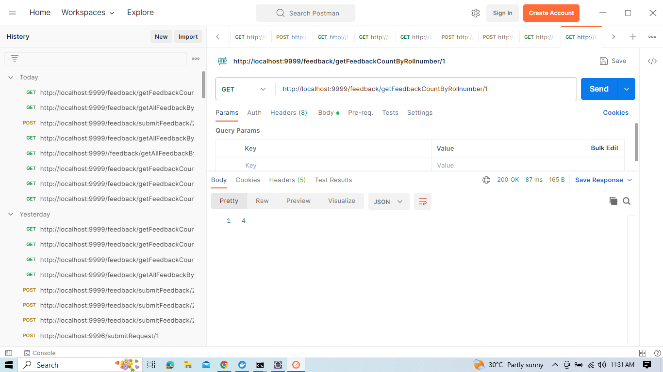

**getAllFeedbackByHostel:**

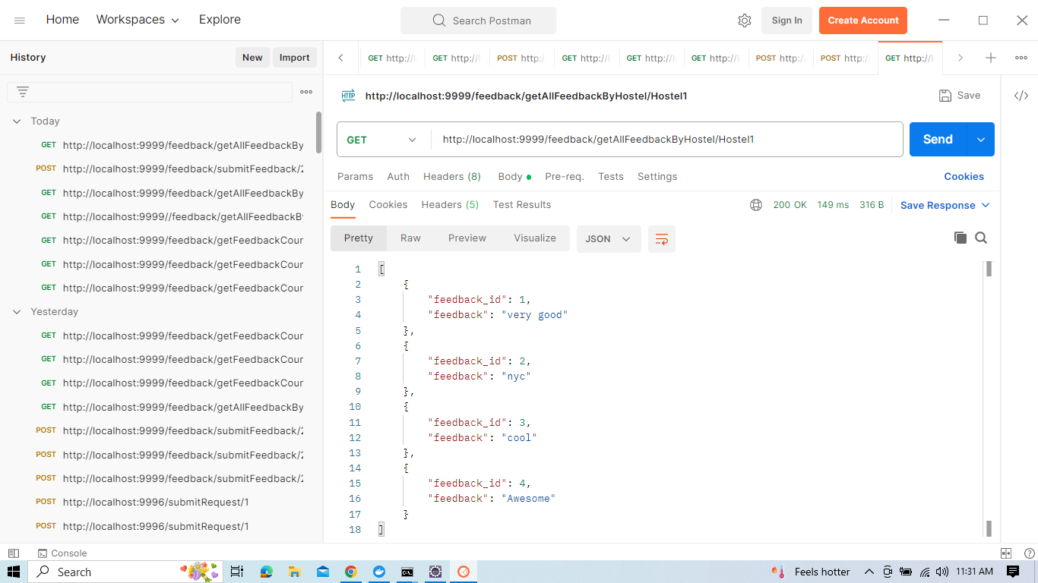

**submitFeedback:**

